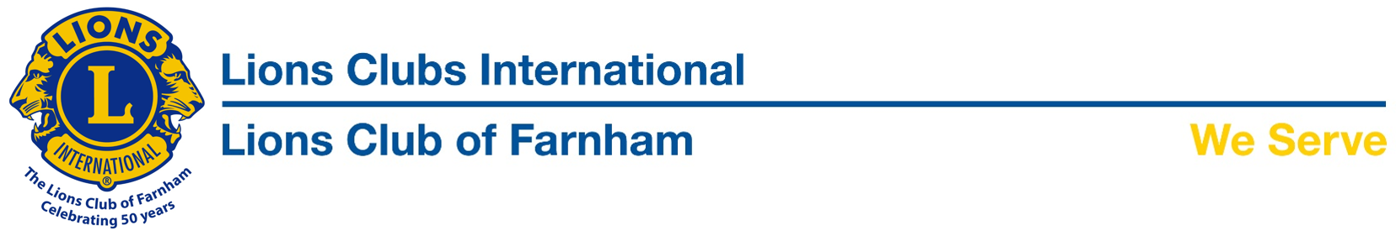

Easter Eggstravaganza Presentation

Well done Badshot Lea Working Men’s Club!

The 2017 Farnham Lions Easter Eggstravaganza appeal raised over £6000 to support Kent Surrey and Sussex Air Ambulance. Amongst the many businesses and organisations supporting the appeal were the members of the Badshot Lea Working Men’s Club who, encouraged by staff members Annette, Rachel and Mandy, raised a fantastic £450.
On Thursday we were pleased to present them with 2 passes to this year’s Weyfest, kindly donated by Richie Elmer and which the club are going to use as their main raffle prize in their up and coming annual 'Joe Kay' day in memory of a lifelong member who sadly passed away a couple of years ago. The money collected from the tickets and fun sports day will contribute to the Children with Cancer UK Charity.

Our thanks go out to all who supported this year’s appeal, every penny of which is donated to KSSAA.

